**CHAROTAR UNIVERSITY OF SCIENCE &**

**TECHNOLOGY**

**DEVANG PATEL INSTITUTE OF ADVANCE TECHNOLOGY & RESEARCH**

**Computer Science & Engineering**

**NAME: PARTH NITESHKUMAR PATEL**

**ID: 19DCS098**

**SUBJECT: DESIGN AND ANALYSIS OF**

**ALGORITHM**

**CODE: CS 351**

**BACKTRACKING**

**PRACTICAL-7.1**

**AIM:**

Implement a program to print all permutations of a given string.

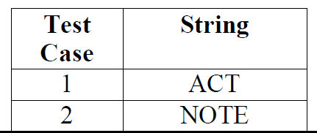

**PROGRAM CODE:**

#include <iostream>

#include <string.h>

using namespace std;

void swap(char *x, char *y)

{

    char temp;

    temp = *x;

    *x = *y;

    *y = temp;

}

void permutation(char *a, int l, int r)

{

    int i;

    if (l == r)

        cout << a << endl;

    else

    {

        for (i = l; i <= r; i++)

        {

            swap((a + l), (a + i));

            permutation(a, l + 1, r);

            swap((a + l), (a + i));

        }

    }

}

int main()

{

    char str[10];

    cout << "ENTER THE STRING : ";

    cin >> str;

    int n = strlen(str);

    permutation(str, 0, n - 1);

    cout<<endl;

    cout << "PARTH PATEL\n19DCS098";

    return 0;

}

**OUTPUT:**

**Test Case-1:**

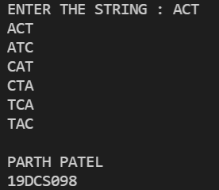

**Test Case-2:**

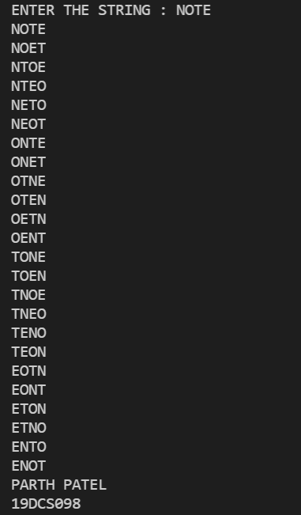

**CONCLUSION:**

By performing the above the practical, we learnt how to programmatically find the permutation of strings.